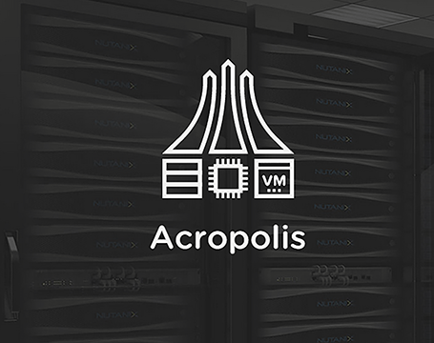

**Workshop Acropolis Hyper Visor**

For supporting NPP understanding – based on the Nutanix CE version

# Acropolis Hyper Visor Workshop

## NPP supporting hands-on document

This demo guide is showing Acropolis Hyper Visor (AHV) based on the Nutanix CE version.

Login to the cluster by its IP Address. Use the table below.

|  |  |  |  |  |  |
| --- | --- | --- | --- | --- | --- |
| **Clustername** | **IP Address CVM** | **IP Address Hyper-Visor** | **VM Name** | **Container 1** | **Container 2** |
| CE1 | 172.25.209.121 | 172.25.209.120 | ub-srv-ce1 | vms-ce1 | DR-vms-ce2 |
| CE2 | 172.25.209.126 | 172.25.209.125 | ub-srv-ce2 | vms-ce2 | DR-vms-ce1 |
| CE3 | 172.25.209.131 | 172.25.209.130 | ub-srv-ce3 | vms-ce3 | DR-vms-ce4 |
| CE4 | 172.25.209.136 | 172.25.209.135 | ub-srv-ce4 | vms-ce4 | DR-vms-ce3 |
| CE5 | 172.25.209.141 | 172.25.209.140 | ub-srv-ce5 | vms-ce5 | DR-vms-ce6 |
| CE6 | 172.25.209.146 | 172.25.209.145 | ub-srv-ce6 | vms-ce6 | DR-vms-ce5 |
| CE7 | 172.25.209.151 | 172.25.209.150 | ub-srv-ce7 | vms-ce7 | DR-vms-ce8 |
| CE8 | 172.25.209.156 | 172.25.209.155 | ub-srv-ce8 | vms-ce8 | DR-vms-ce7 |

Username to be used is **admin** and the password is **nutanix/4u** .The below screen should appear after logging in.

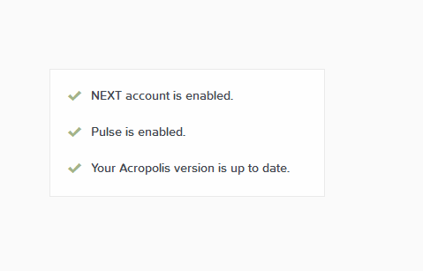

Then the HOME View should appear

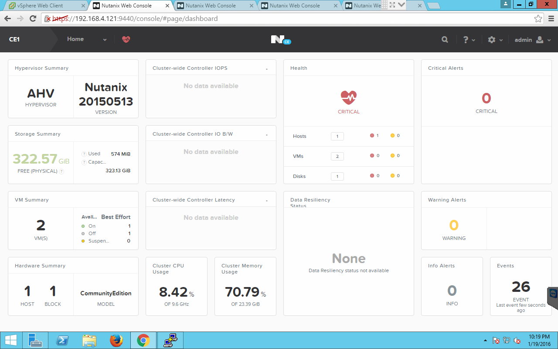

# Create StoragePool

The first to be taken to put information on the Nutanix cluster is do define storage. Step 1 is to create a StoragePool. This will combine all drives (SSD and HDD) into a pool.

To start the first step, click **Home** on the top of the screen and select **Storage**.

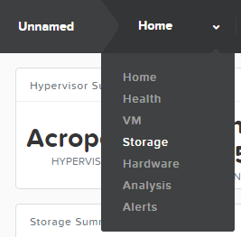

The following example screen should appear.

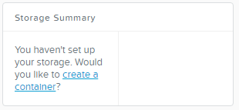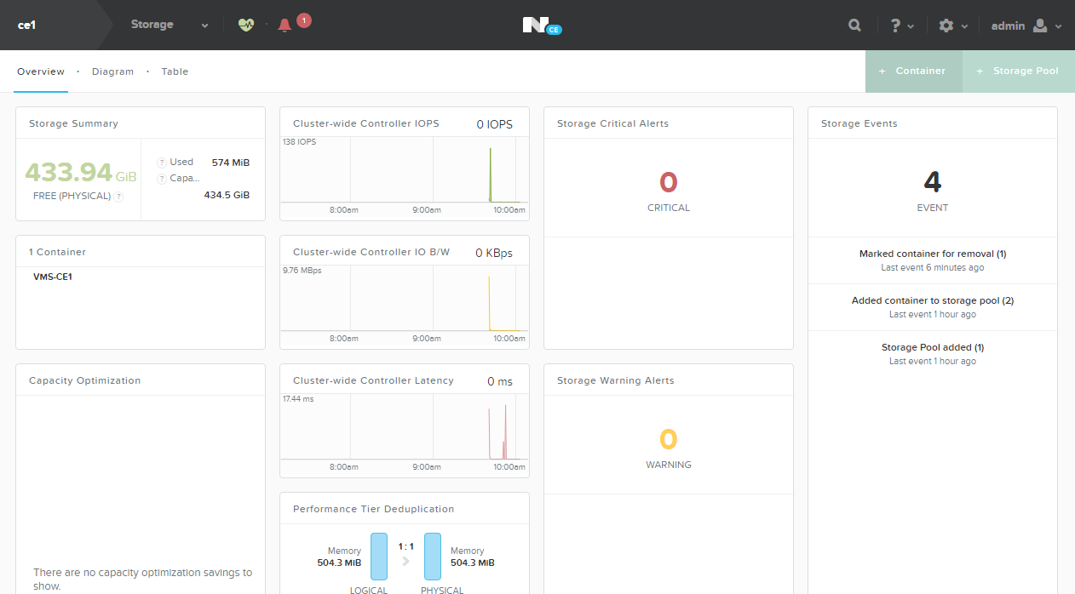

Click on the right hand side of the screen on the green **+ Storage Pool** button to create one.



Give the Storage Pool a name like below.

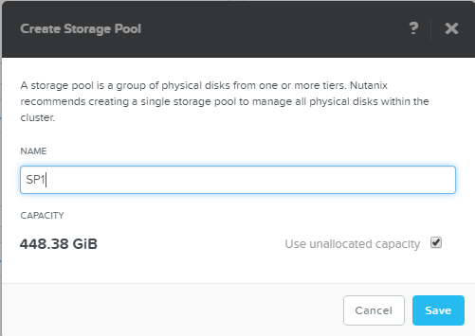

On the top of the screen the below “dropdown” should be seen.

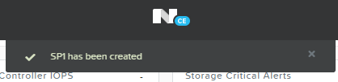

# Create Containers

As a Storage Pool has been created containers can be created. In the overview screen like below, click on **+ Container** to create a container.

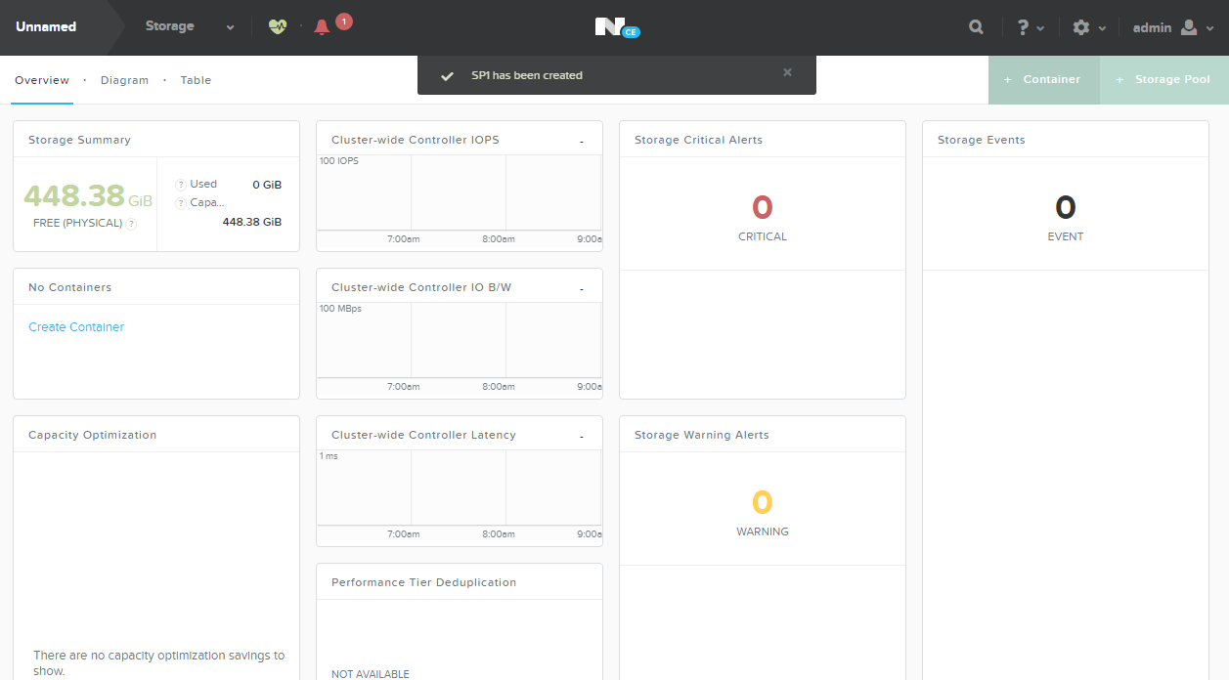

Name the container according to the earlier mentioned table in the naming convention *vms-<clustername>*. Below is a screenshot of the cluster ce1

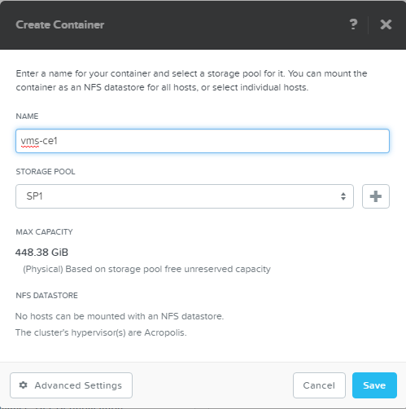

Click on the **Advanced Settings** button to see other parameters that can be set on a per container bases. Just have a look at all the options you can tick.

**REMARK: Keep the settings to default as the demo is running CE with limited resources during this workshop.**

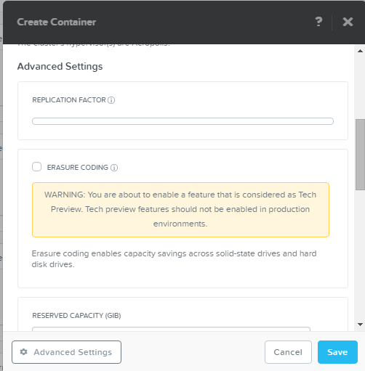

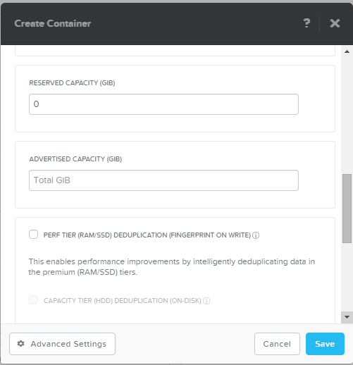

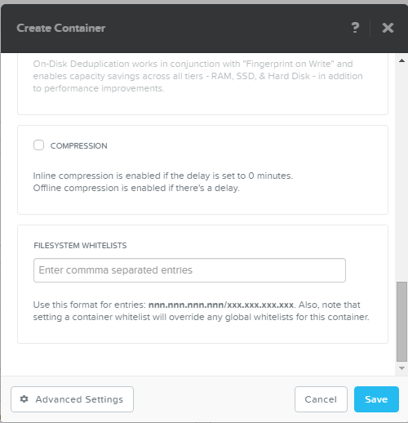

Also create a second container for the replication part of this workshop according to the same table as mentioned earlier, for the replication partner. Naming convention should be: *DR-vms-<clustername partner>*. The below screenshot is using the ce2 cluster as its replication partner.

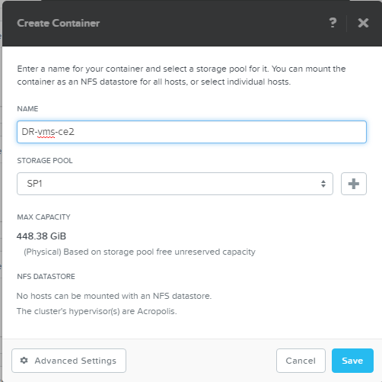

**THIS CONCLUDES STORAGE RELATED SECTION OF THIS DOCUMENT**

# Creating a Virtual Network

Change the View to VM and click **“Network Config”** on the right side of the screen. We need networking, so we need to create virtual networks first.

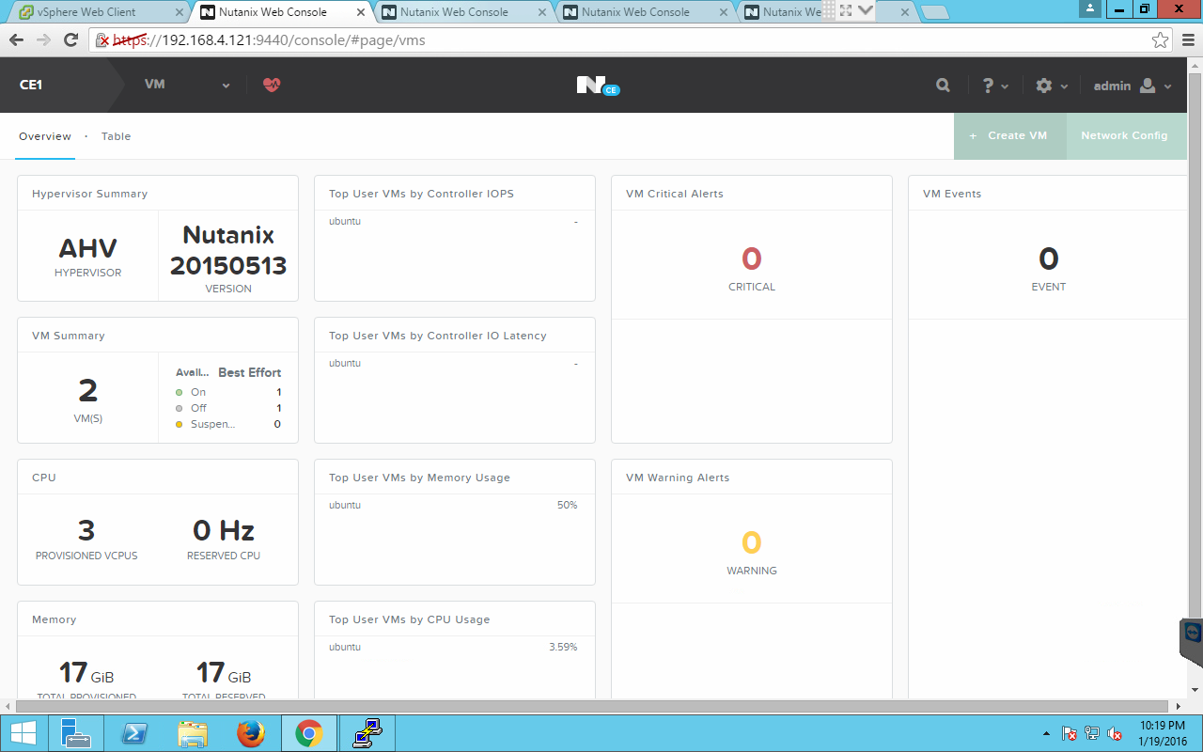

In the screen below hit the **+ Create Network** button to create a new virtual network.

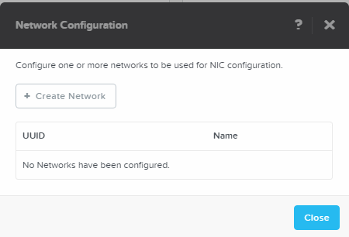

Fill the needed fields (use the below value as an example):

**Name: vlan0**

**VLAN ID: 0**

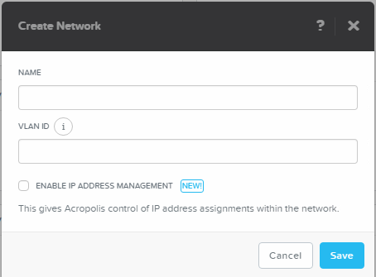

Check the **ENABLE IP ADDRESS MANAGEMENT** checkbox to see what else can be configured in the virtual network. Use again as an example the values in the screenshot

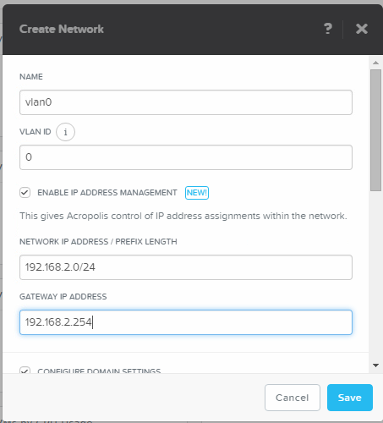

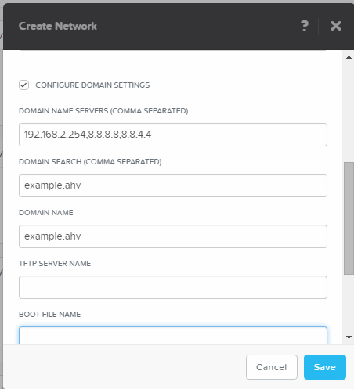

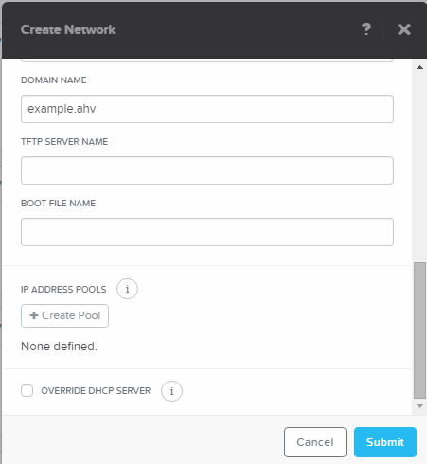

To create a DHCP-Pool in the virtual network, click the **+ Create Pool** button and use the below values again as an example

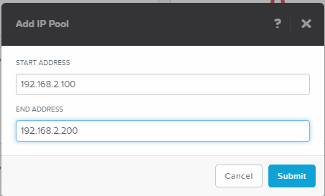

When done, click the Submit button

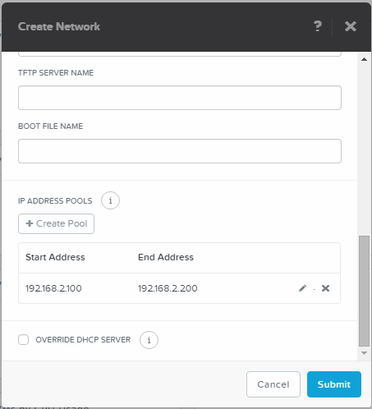

The screen should now look like the above screenshot. Now click the Submit again to get the virtual network created in the AHV environment.

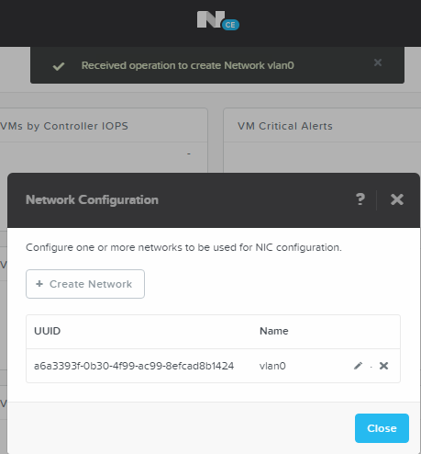

From the top a screen should drop down to tell that the network has been created, and the **Network Configuration** screen should show the just created network with its UUID and name. If you want to change anything just click the Pencil Icon right to the name of the virtual network. Repeat as many as needed.

# Creating a VM in AHV.

Back in the VM View, Click the **+ Create VM** button on the right side of the screen.



The below screen will pop up. Use the values in the screenshot for your VM you going to create. For the name please use the following namingconvention:

*ub-srv-<name of the cluster>* example for cluster ce1 **ub-srv-ce1** as shown below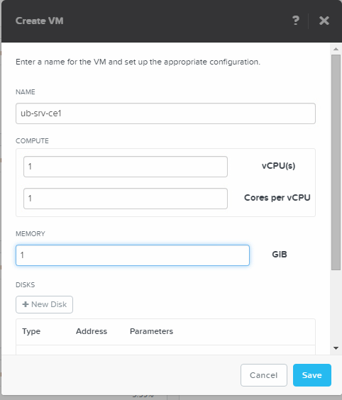

Define a disk so we can write data to the VM. Hot the **+ New Disk** button to create as many disk one at a time as we need for the VM.

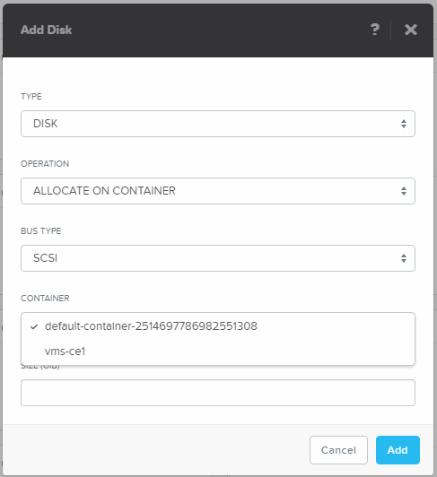

Change the container to the one we’ve created earlier. If you haven’t created it, Cancel this action and go to the Storage View and create a container quickly. Name it vms-<clustername>. As an example on cluster 1, called CE1, you create a container called vms-**ce1**, and return to the VM creation and disk creation screen like above.

Create a 10GB disk in the right container. Create a 10GB disk

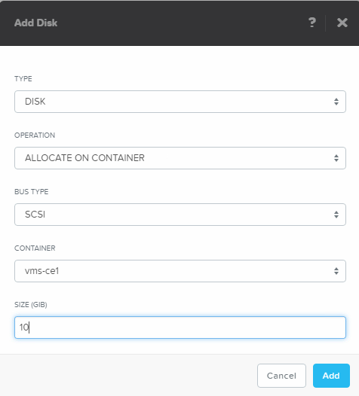

Now let’s change the CD to something useful instead of an empty one. Click the pencil button just right to the CDROM

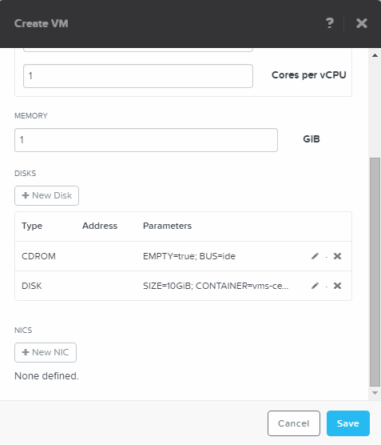

A new screen will appear

Change the OPERATION into **CLONE FROM IMAGE SERVICE**

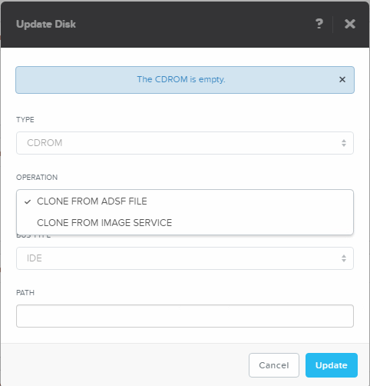

As there is no ISO image yet in the cluster we need to upload one. Click the **Add Image** text

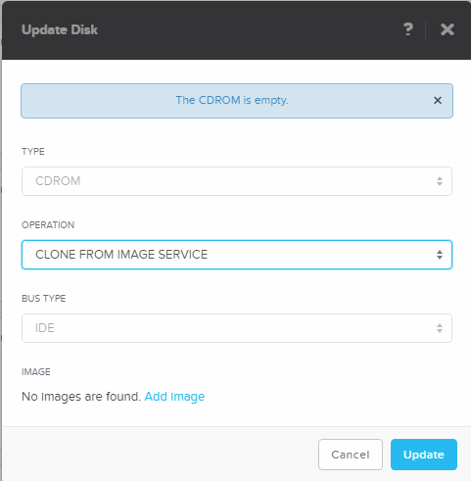

A new screen will appear. Click the **+ Upload Image** button.

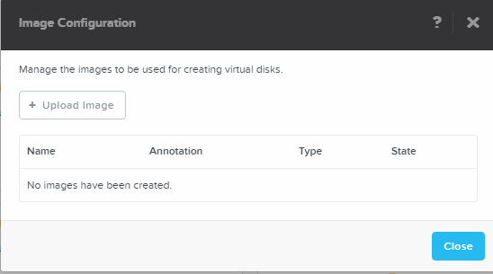

Give the too be uploaded ISO a name which is easy to understand what the image is all about. As an example use the below parameters and change the **IMAGE TYPE** to ISO like below. Also make sure you use the right container and select the **Upload from file** radio button and click on Choose File to search the right ISO too be uploaded.

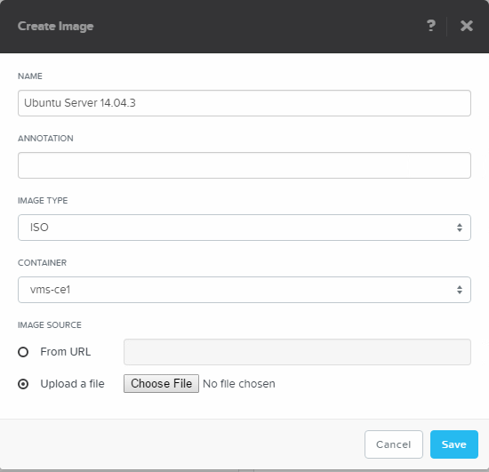

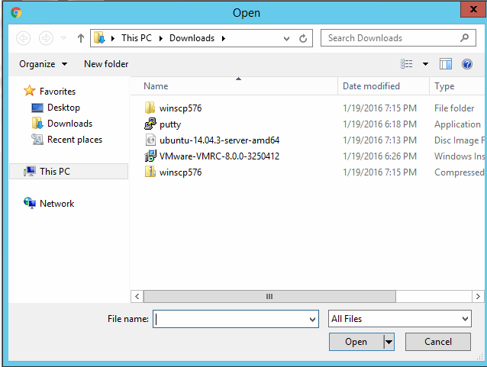

Search for the ISO file and click the **Open** button.

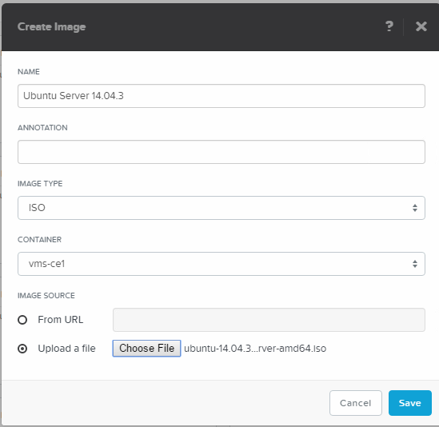

Click the **Save** button to upload the ISO file into the cluster. The below screen will appear to show the progress of the upload.

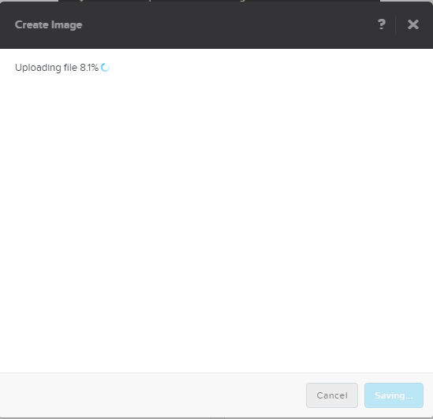

And will end with the below screenshot.

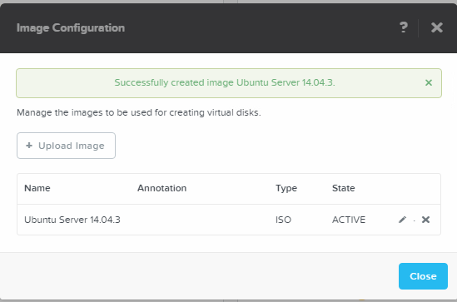

Click the **Close** button to return to the CDROM setting of the VM.

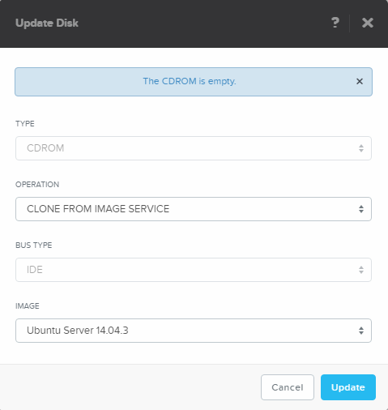

Click the **Update** button to return to the VM definition.

If you want to change uploaded ISO images after creation of the VM, click on the gear-icon in the top right hand corner and select **Image Configuration**.

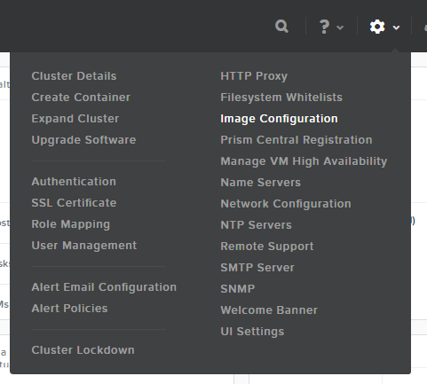

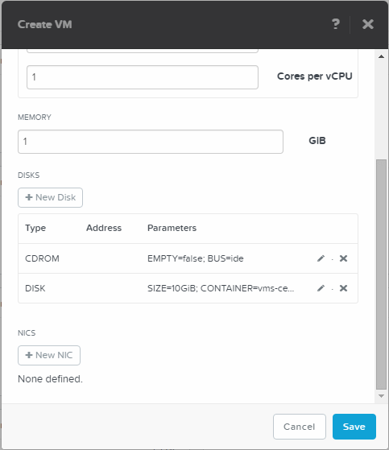

As this is an example we are going to use the earlier created virtual network. Click  **+ New NIC** to add a network connection to one of the created virtual networks

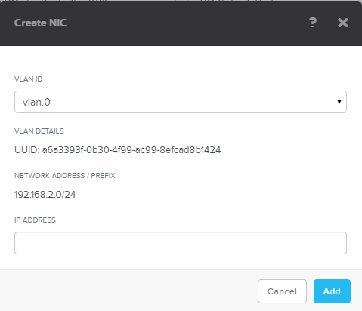

Click the **Add** button to have the network connection added to the VM.

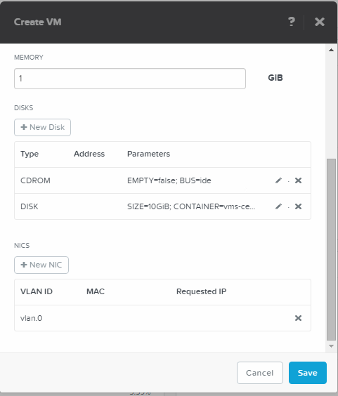

Now click the **Save** button to have the VM be created. The below screen should be seen from the top coming down slowly. This will show you that a VM ub-srv-ce1 has be created.

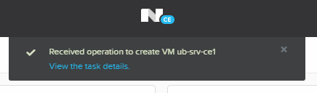

In the tableview we were in we should no see our just created VM.

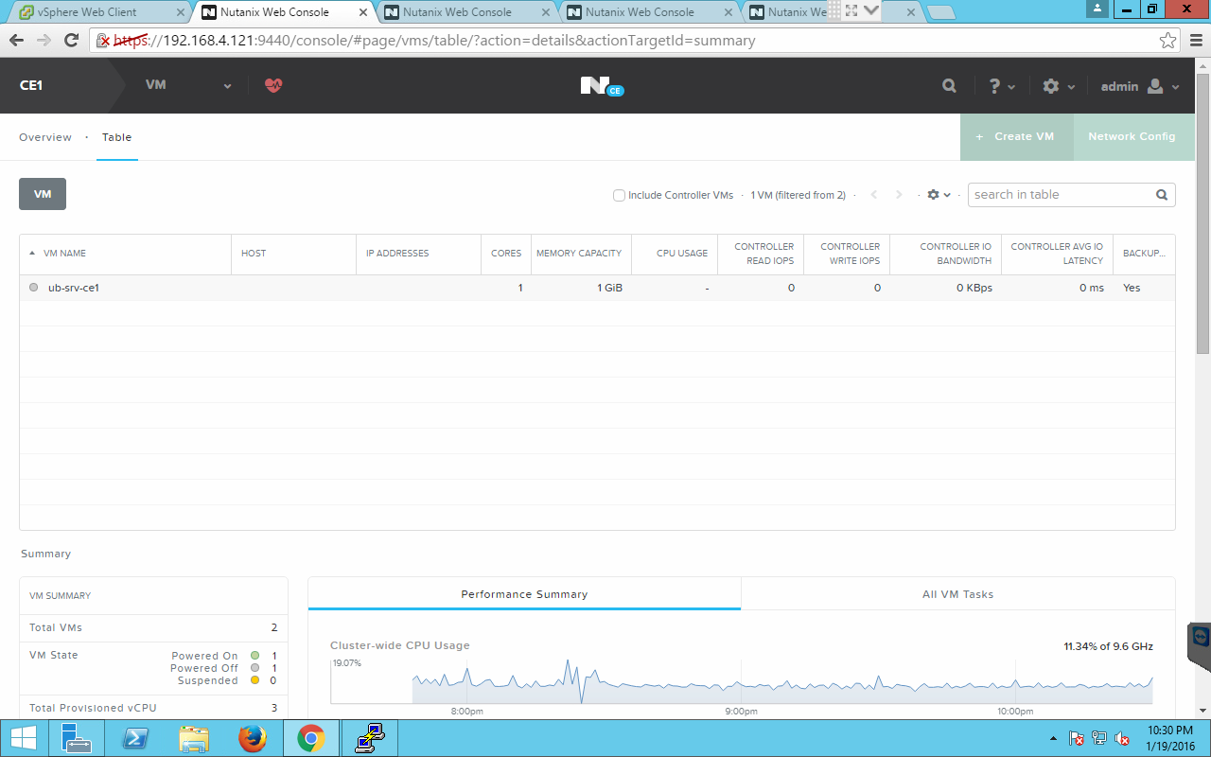

Now let’s start the VM. Hit the **Power On** button halfway of the page after having the VM selected!.

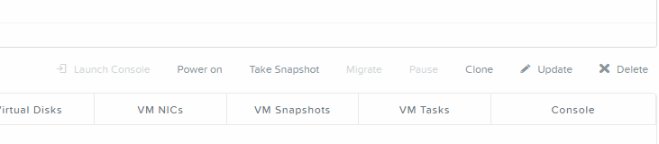

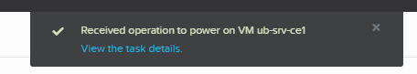

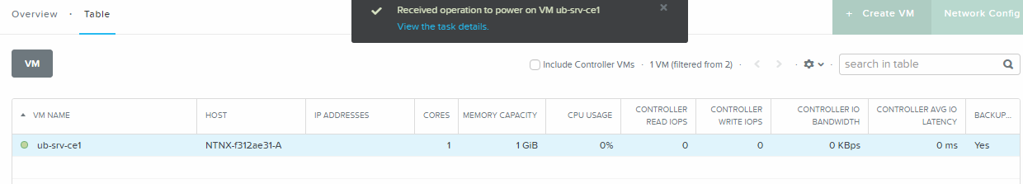

After having the machine given the Power On status, a host will appear in the table view. Not sooner!

Now hit the **Launch Console** button to the left side of the **Power On** button to see the console of the VM.

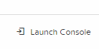

A VNC screen will open top show the console of the VM.

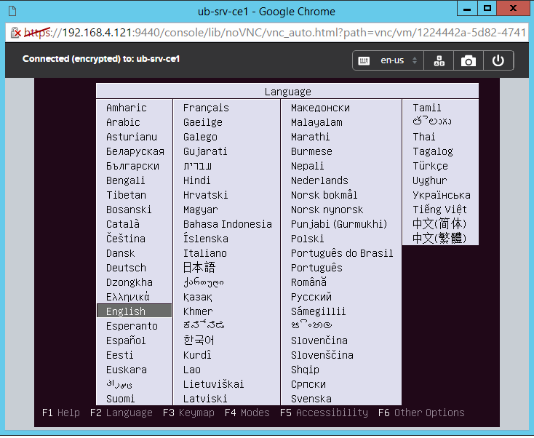

If you want, test all button on the right-hand side of the VNC console to see what they do.

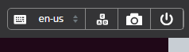

**THIS CONCLUDES THE CREATE VIRTUAL NETWORK AND VM SECTION OF THIS DOCUMENT**

# VM Cloning

Let’s clone a VM using the PRISM interface. Click the **Clone** button kin the PRISM interface.

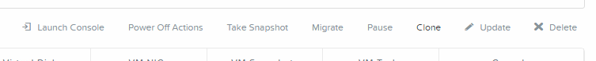

Use the below settings for the clone use for the name the original name and add **-clone** to it. Look at all options you can change!

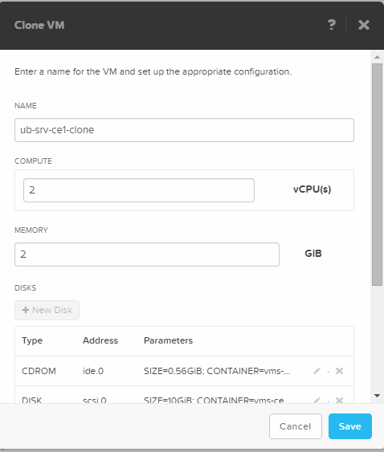

After you have clicked the **Save** button the VM clone should appear in the PRISM UI like below.

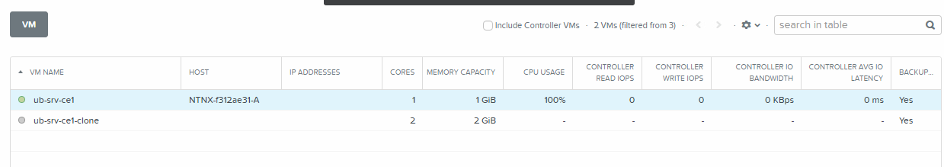



Look at all the options you can monitor after you’ve clicked on one of the VM’s. Information should be there for the first created and powered-on VM.

**THIS CONCLUDES THE VM CLONING SECTION OF THIS DOCUMENT**

# AHV Scripting

AHV is very powerful from a scripting interface the so called acli. The flowing section is providing some basic scripts/commands that can be used in the acli interface.

## VM Creation - Basics

Connect to the CVM using the IP address of your cluster. Use **nutanix** and the **nutanix/4u** as username and password combination.

After the connection is successful type the following command to create a VM with 1G of RAM, 1vCPU and a 10GB disk. For demo purposes the CDROM and the NIC are not used but can be added if wanted. For a full reference to all acli command’s look in the Application Mobile Fabric guide on the support site.

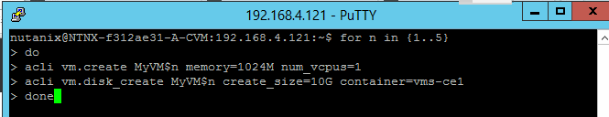

This command should lead in having 5 VM’s named MyVM1 to MyVM5 all with the earlier mentioned parameters. The below screen shows all lines returned by the cluster.

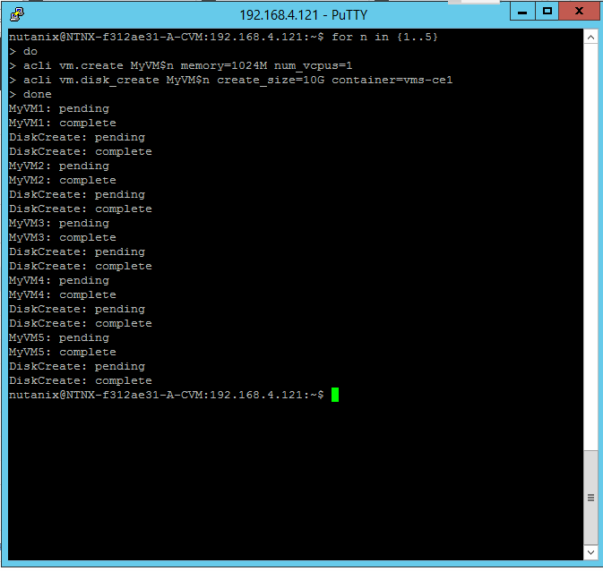

PRISM will show all just 5 newly EXTRA created VM’s

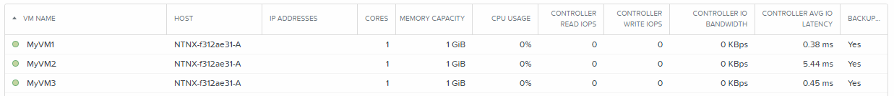

## VM Cloning

Before we can clone machines, we need to get some resources freed-up. So power done the earlier created clone using the UI named ub-srv-cex by using the **acli vm.off** command

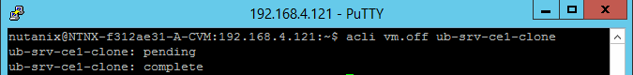

The PRISM should show a gray coloured icon infront of the VM like below.

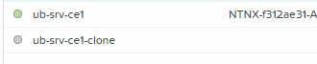

Now let’s delete that VM by using the **acli vm.delete** command and reply **yes** to the asked question if you are sure.

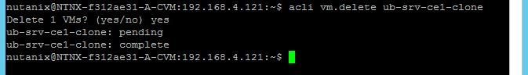

Also delete all earlier created MyVM1 till 5 using the acli vm.delete MyVM[1-4] command like below and reply with yes as well.

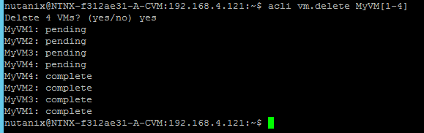

In the PRISM UI the VM’s should be gone except for two.

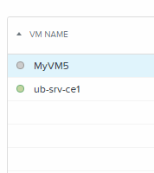

No let’s clone the MyVM5 into 5 new machines called MyVMClone1 to MyVMClone5 by using the **acli vm.clone** command as shown below.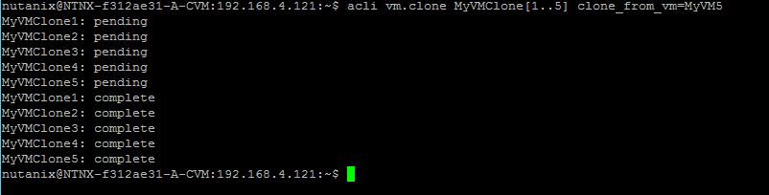

PRISM should show

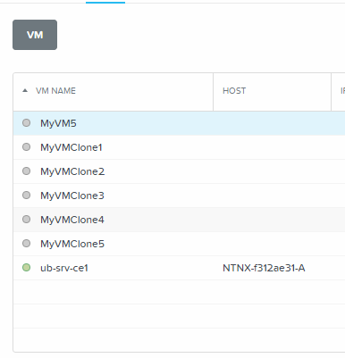

Let’s power on the first three just created VM’s by using **acli vm.on MyVMClone[1-3]** command like below.

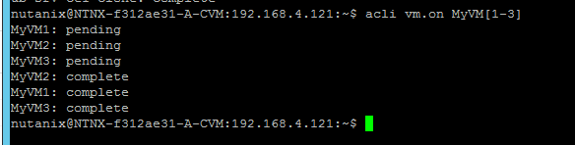

PRISM should show the VM’s with a green ball in front of the VM.

Now let’s delete all earlier created VM by using the **acli vm.delete** command using wildcards like below and answer the question asked with **yes**.

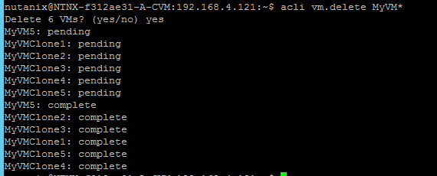

Only one VM should exist in the cluster.

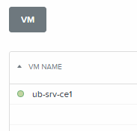

**THIS CONCLUDES THE AHV BASIC Scripting SECTION OF THIS DOCUMENT**

# Replication – A-Synchronous

For this section you will be working with another cluster to start A-Synchronous replication using two CE installations. Use the below table to get the information needed.

|  |  |  |  |  |  |
| --- | --- | --- | --- | --- | --- |
| **Clustername** | **IP Address CVM** | **IP Address Hyper-Visor** | **VM Name** | **Container 1** | **Container 2** |
| CE1 | 172.25.209.121 | 172.25.209.120 | ub-srv-ce1 | vms-ce1 | DR-vms-ce2 |
| CE2 | 172.25.209.126 | 172.25.209.125 | ub-srv-ce2 | vms-ce2 | DR-vms-ce1 |
| CE3 | 172.25.209.131 | 172.25.209.130 | ub-srv-ce3 | vms-ce3 | DR-vms-ce4 |
| CE4 | 172.25.209.136 | 172.25.209.135 | ub-srv-ce4 | vms-ce4 | DR-vms-ce3 |
| CE5 | 172.25.209.141 | 172.25.209.140 | ub-srv-ce5 | vms-ce5 | DR-vms-ce6 |
| CE6 | 172.25.209.146 | 172.25.209.145 | ub-srv-ce6 | vms-ce6 | DR-vms-ce5 |

We start by creating a Remote Site and then a Protection Domain.

## Remote Site creation

To get A-Sync running we firstly need to define a remote site. Click on **Data Protection** in de main screen bar.

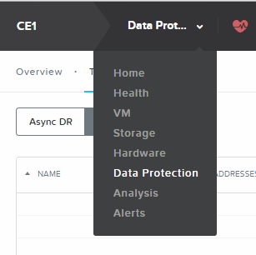

On the right-hand side click on the **+ Remote Site** and then on **Physical Cluster** as the sync partner is a “physical cluster”.

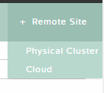

**REMARK: The screenshots further on in this document use CE1 as the source and the CE2 cluster as the remote side for example reasons!**

In the Remote Site screen type the information of the partner cluster. Give the remote site a name which makes the remote site understandable where and what it is. Also provide the IP address of the partner cluster and click Add Site.

**REMARK: In real live production environments use the External IP address of the cluster. In our demo environment we use the IP address of the CVM as we only have one node in the Nutanix Cluster.**

**REMARK: As we are working in pairs the other partner cluster will have your cluster as the remote site defined so we don’t need to do anything on that cluster as mentioned in orange just below the NAME field in the screen. In production time you MUST do this. Otherwise the replication will fail!**

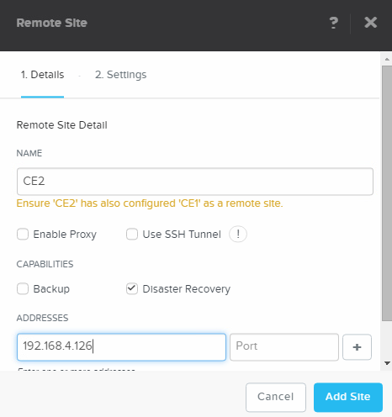

The below dropped down screen should been seen.



The screen, after clicking on the **Save** button should show a green text stating that the Remote site has been created successfully. Scroll down and leave all setting default till you see **NETWORK MAPPING** and **VSTORE NAME MAPPING** as we need to tell the cluster how to map these two.

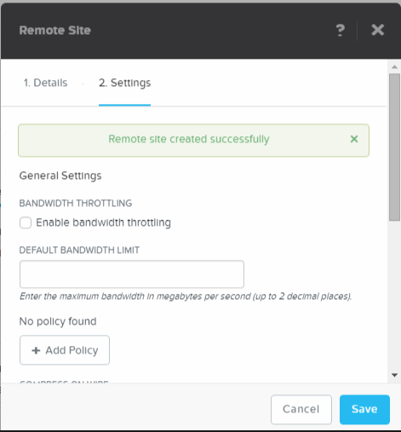

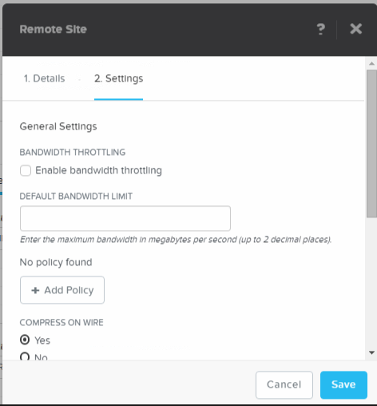

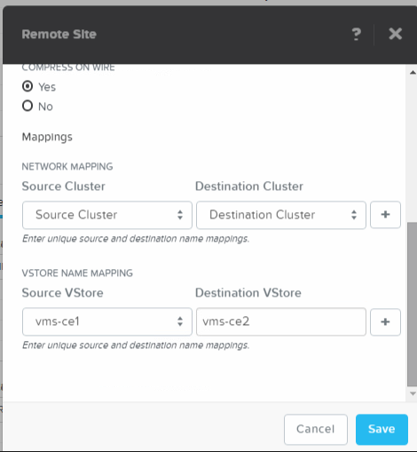

For network mapping we need to tell the cluster how to map the networks on both cluster to each other. This has to be done if the networks on both cluster are not named the same. In our environment we use AHV-vlan0 and both.

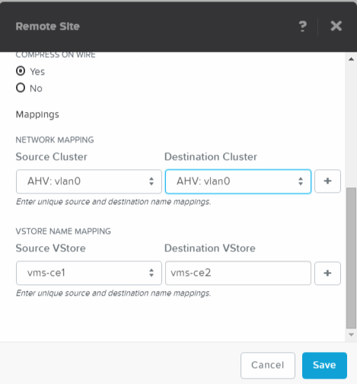

For the **VSTORE NAME MAPPING** we need to tell the mapping between **Source VStore** and **Destination VStore**. In our environments we need to change these to the below screenshot. Again use your parameters according to the table earlier. As example in the screenshot vms-ce2 on *ce2* is mapped to DR-vms-ce2 on the *ce1* cluster.

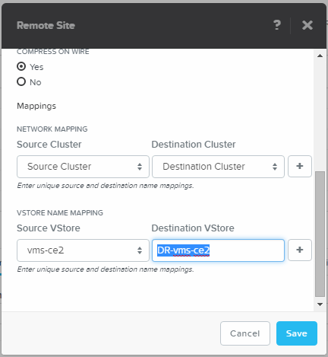

**REMARK: The OS on which the CVM is running is CASE SENSITIVE. Make sure you use the right upper and lower characters as mentioned in the clusters.**

**TIP: Open both clusters in a browser and select and copy the name of the cluster so you don’t make any mistakes.**

After creation of the Remote Site the below screenshot should be shown where you see the settings which you have created earlier. If you don’t see this, click on the Table view and then on Remote Site.

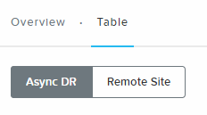

After selecting the Remote Site you just created you should be able to use the **Test Connection** button. If you’ve created the remote site correctly, you should see a **green checkmark** left to the button like below screenshot.

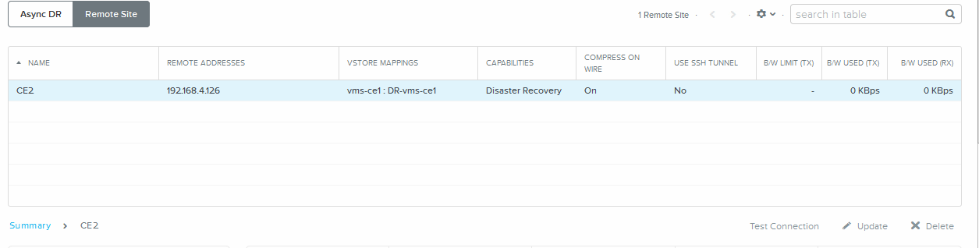

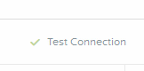

## Creating a Protection Domain

When clicking on the **Async DR** button there should not be shown anything.



On the right hand-side of the screen click on the **+ Protection Domain** and the on **Async DR**.

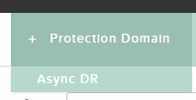

A new screen appears in which a name is asked for. Give the Protection Domain a useful name like CE1-CE2 and click the **Create** button.

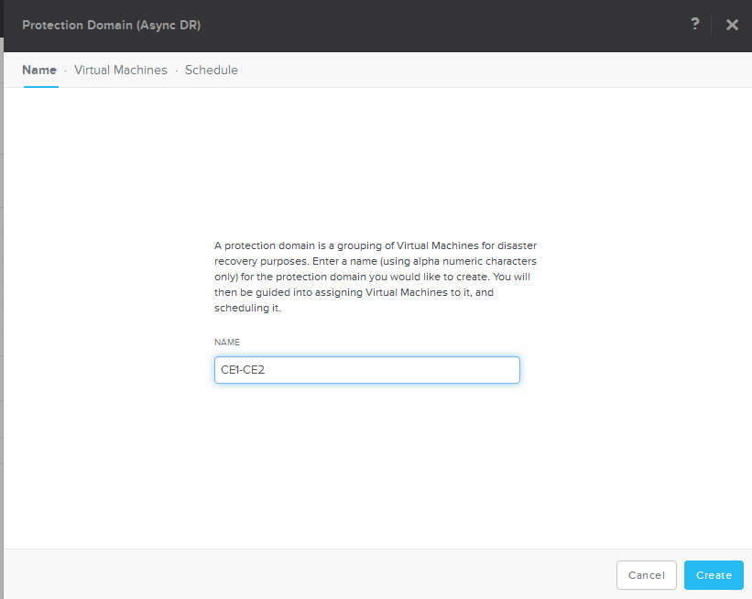

The next phase will be to assign VM’s to the Protection Domain. Select the **ub-srv-cex** VM which you created earlier and click on the **Protect Selected VMs** button.

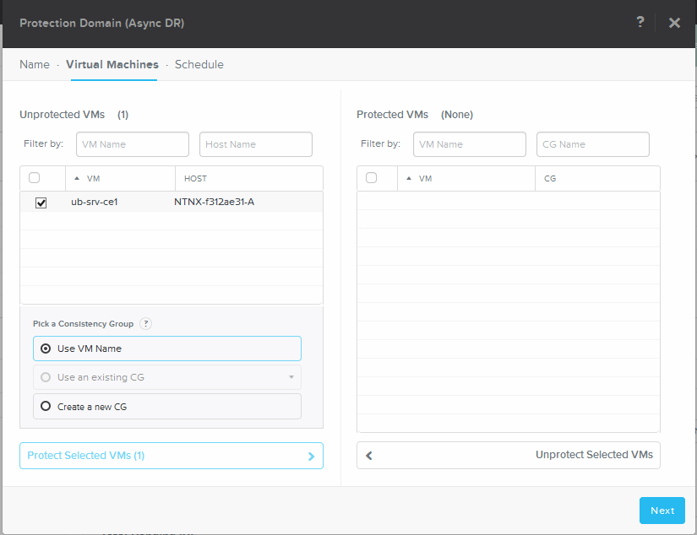

This should end up in a screen like below. Click the **Next** button.

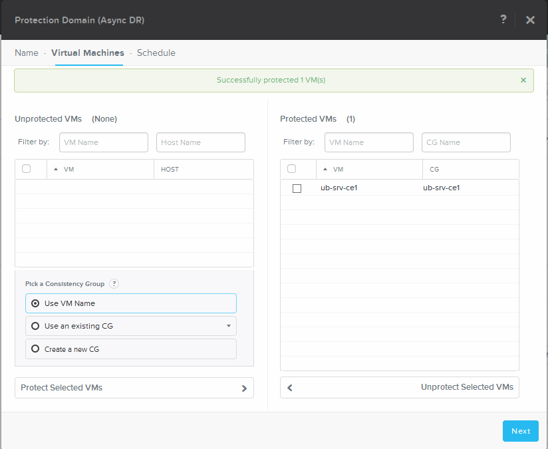

Now we need to tell the cluster according to which schedule it has to make snapshots and should they be replicated to another remote site. Click the **New Schedule** button.

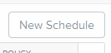

Try to create a repeatable time smaller than 60 minutes like below.

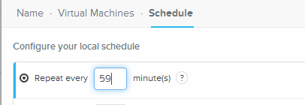

This should return an error as soon as you click on another parameter in the top of the schedule.



**REMARK: The lowest number which can be set in the minutes is 60 minutes!**

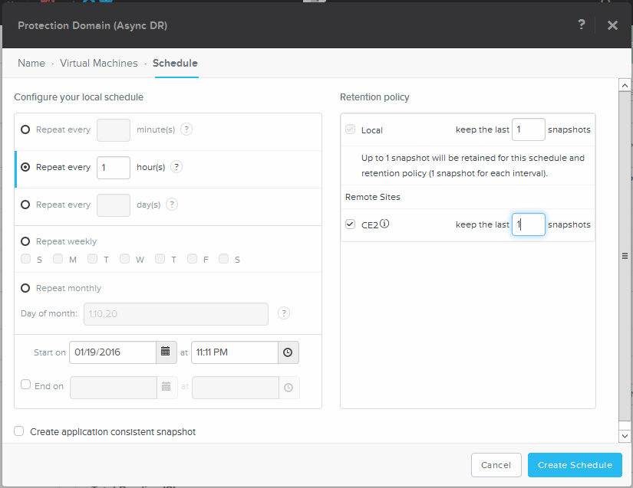

Set the parameters according to above screenshot and click the **Create Schedule** button.

This should result in a screen just like below.

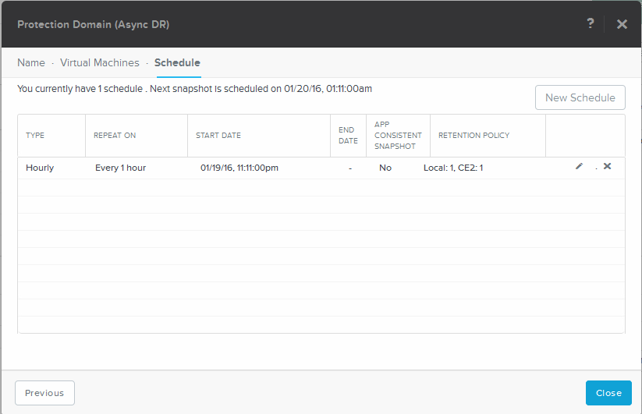

Click the **Close** button to close the creation of the Protection Domain.

## Test the Replication

To test all simple click on the **Async DR** button and select the protection domain we’ve just created.

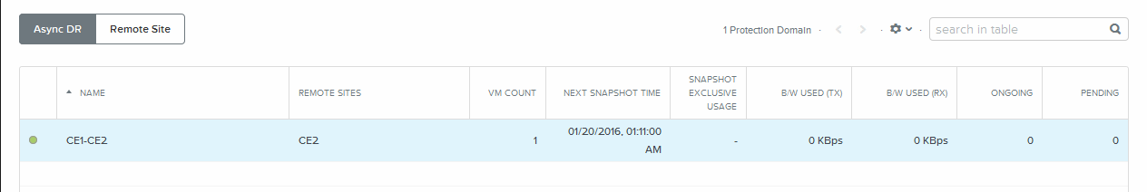

The **Take Snapshot** button should now be available. Click this button.

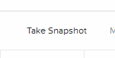

Now let’s create a snapshot of the VM in the selected protection domain and set the settings to the below screenshot. This will result in a snapshot be create, replicated to the remote site, scheduled now and with a retention of 1 day. Don’t forget to select the **REMOTE SITES** otherwise ther will only be a local snapshot created. Click on **Save** when done.

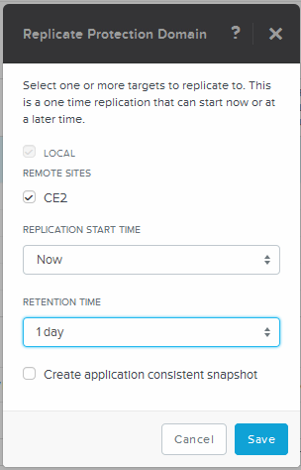

That click should provide a dropped down screen stating that the schedule has been created.

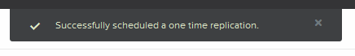

Select the protection domain again and then look at the Replications tab. There should be a line stating what it is doing.

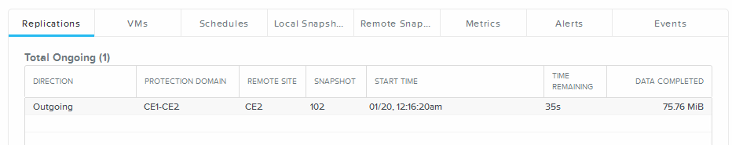

If the replication has worked and is completed, there will be in the same tab of **Replications** at mention of this lower in that subscreen. Example is below.

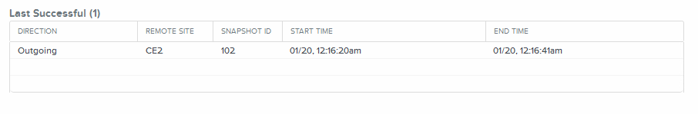

Take a look at all tabs which are available.

**VMs** tab

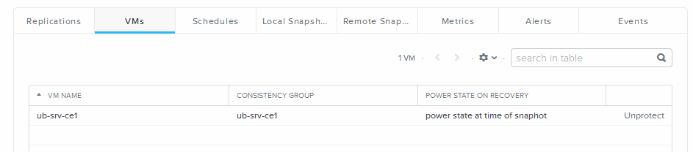

**Schedules** tab

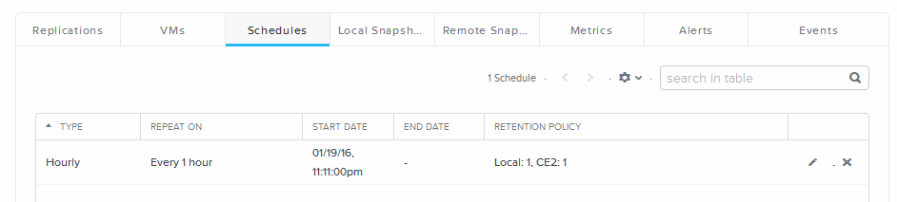

**Local Snapshots** tab 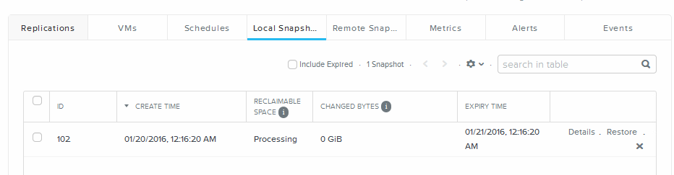

**Remote Snapshots** tab

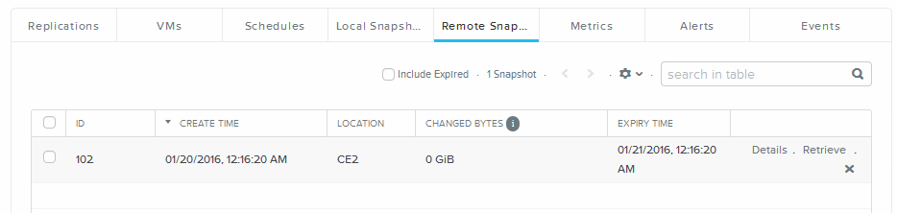

**Alerts** and **Events** tab.

If it didn’t work, use the Alerts tab to see what is wrong.

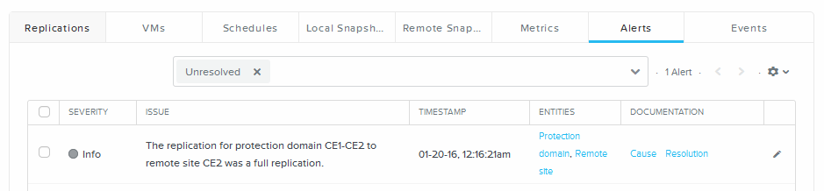

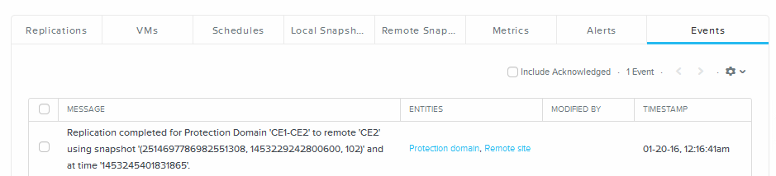

On the left hand-side of the bottom half of the screen you will find Summary information of the protection domain.

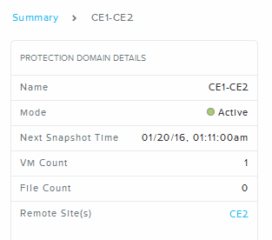

**THIS CONCLUDES THE REPLICATION – A-SYNCHRONOUS SECTION OF THIS DOCUMENT**